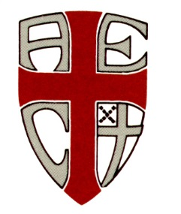 | 2021-22  William Randolph Hearst Episcopal Scholarships

for seniors planning to attend an Episcopal college or university

The Rev’d Canon James G. Callaway, D. D., General Secretary of the Colleges and Universities of the Anglican Communion (CUAC) and the Association of Episcopal Colleges (AEC), announces the 2020-21 Episcopal Colleges William Randolph Hearst Service Learning Scholarships. An annual $10,000 scholarship (distributed over four years) will be awarded to an Episcopal high school senior graduating in 2021 and matriculating at an Episcopal college.
To qualify, applicants must be outstanding Episcopal students at an institution belonging to the National Association of Episcopal Schools. They must have demonstrated experience in Service Learning and community service and must be planning to attend one of these eight Episcopal colleges and universities:
- Bard College (Annandale-on-Hudson, NY)
- Hobart and William Smith Colleges (Geneva, NY)
- Kenyon College (Gambier, OH)
- St. Augustine College (Chicago, IL)
- St. Augustine’s University (Raleigh, NC)
- The University of the South (Sewanee, TN)
- Voorhees College (Denmark, SC)
- Université d’Haiti (Port-au-Prince, Haiti, WI)

Background and Criteria
Established in 1997 by the William Randolph Hearst Foundation, these awards emphasize learning through service and seek to recognize students who have been active Episcopalians in their high school and/or home parish.
Applicants must be able to demonstrate a strong record of Service Learning and community service, along with academic achievement in their junior and senior years, outstanding leadership, and a commitment to worship and community life in their school and home parish. Other requirements and instructions detailing the application process are listed on the application form, available for download at www.cuac.org.
Applications must be postmarked by Saturday, February 13, 2020, for students entering college in fall 2021. Award decisions will be announced in late March 2021.

PLEASE POST

