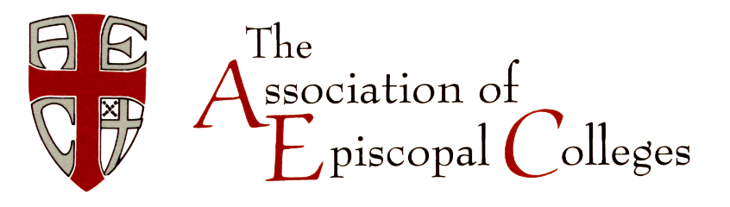

***The story of the family known as the Association of Episcopal Colleges,***

***each of which was founded for a distinctive purpose:***

It begins in 1822 when in a single year the third Bishop of New York, John Henry Hobart, trekked 5,000 miles by horseback, foot, and packet missionizing his vast Empire state, he discovered that in bustling Geneva, New York the Geneva Academy had closed and he found funds from Trinity Church in New York where he was rector to reopen what became Hobart College for men, broadened in 1908 when a local philanthropist William Smith gave the funds to open a coordinate college for women, becoming **HOBART AND WILLIAM SMITH COLLEGES**.

In 1824 after becoming Bishop of Ohio, Philander Chase finding a lack of trained clergy in the West sailed to England, raising funds from Lord Kenyon, Lord Gambier to open a college and seminary, the first private college in Ohio. Chase purchased 8,000 acres of what would become Mt. Gambier: legend has it that when he was shown the summit he replied, “This will do!” and **KENYON COLLEGE** was birthed.

What was planned to be an Episcopal citadel of learning in the South in 1857 with a six-ton marble cornerstone laid in 1860 that was blown to bits in the violence of the Civil War, but limped into existence when Charles Todd Quintard, the second bishop of Tennessee traveled to England raising funds to re-founded the University in 1866, building **SEWANEE: THE UNIVERSITY OF THE SOUTH** from the ashes of the war.

In the North in 1860, a time of national crisis, John Bard donated a gift of land in what became Annandale-on-Hudson, New York to ensure “that liberal education would be preserved as an important value in the civilization for which the war was fought.” **BARD COLLEGE** prospered, in face of another war in 1944, becoming coeducational.

In 1868 twelve Episcopal priests travelled from North to South to start a school to train freedmen quickly to prepare other freed slaves to teach, opening Saint Augustine’s Normal School and Collegiate Institute in Raleigh, North Carolina, beginning material racial reconciliation by the Episcopal Church. Not only one of the oldest HBCUs, **SAINT AUGUSTINE’S UNIVERSITY** opened St. Agnes Hospital that had the first school of nursing for African Americans in North Carolina and their only hospital until 1960.

In 1889 Samuel David Ferguson, the first Liberian to become the Bishop, with the gift $5,000 from Robert Fulton Cutting, the Episcopal Church treasurer, purchased land for training Liberian children — both Americo-Liberian and native to become the first private, coeducational college in sub-Saharan Africa, now **CUTTINGTON UNIVERSITY** on three campuses.

In 1897 Elizabeth Evelyn Wright, who after her training at Tuskegee Institute by Booker T. Washington had the tenacity to open five rural schools for black students that were burned to the ground before finding hospitality here in Denmark, South Carolina, above a local store in where she opened an industrial school modeled on Tuskegee, that with the purchase of land by New Jersey philanthropist Ralph Voorhees in 1902 became **VOORHEES COLLEGE**.

In 1963, Bishop Lyman Ogilby, the last American bishop of the Philippine Episcopal Church, used seed money donated by Elsie Proctor, granddaughter of the founder of Proctor and Gamble Company, establishing a college in Quezon City that has become **TRINITY UNIVERSITY OF ASIA**.

Finally, in 1995 the Episcopal Church in Haiti turned to higher education to strengthen the futures of Haitian youth, founding the **UNIVERSITÉ EPISCOPALE D'HAITI** in Port-au-Prince, to strengthen the teaching of the scientific, technical and professional, with an agricultural campus in the north, a college of nursing in Léogâne and a school of business in Les Cayes.

The Revd Canon James G Callaway, DD

General Secretary Emeritus

815 Second Avenue, New York, NY 10017-4594 USA Tel: 1 212-716-6148 Fax: 1 212-986-5039 E-Mail: office@cuac.org